Outline:
- Basic Chemistry
  - Periodic Table
  - Bohr Models
  - Ionic and Covalent Bonds
- Water
  - Polarity & Hydrogen Bonds
  - Solutions, Acids & Bases
  - Buffers
- Enzymes
  - Chemical Reactions
  - Activation Energy
  - Enzyme Activity & Regulation
- Organic Molecules
  - Carbon & Polymers
  - Carbohydrates
  - Lipids
  - Proteins

Vocabulary:

Atom
Proton
Neutron
Electron
Nucleus
Ion
Element
Ionic bond
Covalent bond
Compound
Polarity
Hydrogen bond
Hydrophilic
Hydrophobic
Solution
Mixture
Solvent
Solute
Buffer
Monomer
Polymer
Hydrolysis
Dehydration synthesis
Carbohydrates
Monosaccharide
Disaccharide
Polysaccharide
Lipid
Glycerol
Fatty acid
Saturated fat
Unsaturated fat
Amino acid
Protein
Carboxyl group
Amino group
Enzyme
Catalyst
Substrate
Active site
Activation energy

Objectives:
- Compare and contrast:
  - Ionic bonds and covalent bonds
  - Acid and base
  - Hydrolysis and dehydration synthesis
  - Monomer and polymer
- Draw a Bohr Model of an atom
- Explain why molecules are polar molecules and how they form hydrogen bonds
- Determine if substances are acids or bases (based on pH and H+ or OH- ion concentrations). Provide examples.

- Describe the relationship between buffers and homeostasis.

- Explain which properties of carbon make it such an important element in organic compounds.

- Diagram the process of dehydration synthesis and hydrolysis.
- Fill in the following chart for the organic molecules:
 | Elements found in the molecule | Basic Shape & Structure | Functions | Examples
Carbohydrates
Lipids
Proteins

- Explain how enzymes function to speed up chemical reactions (Explain the Lock and Key analogy)
- Describe how environmental factors affect the rate of enzyme activity.
- In the diagrams below:
  - Identify the following structures as lipids, carbohydrates or proteins.
  - Label the functional groups of the amino acid. Describe the properties of each functional group.
  - Label the parts of the triglyceride lipid. Is the lipid molecule saturated or unsaturated? How can you tell?

b.
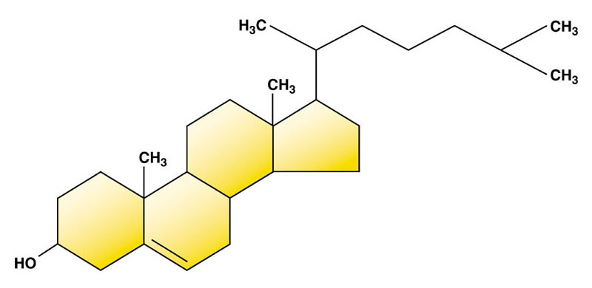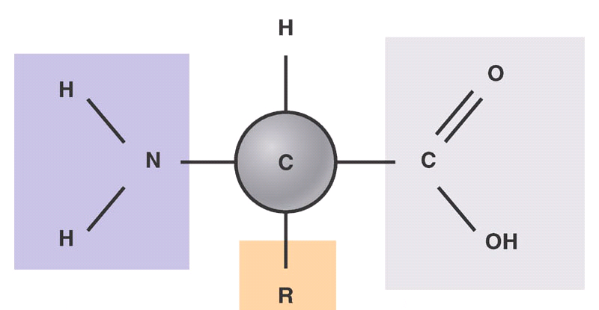
a.

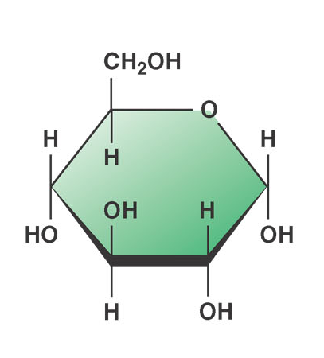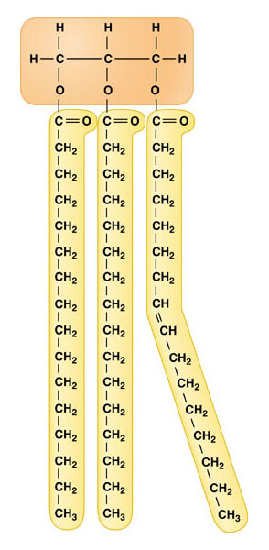
c.
d.

